COGNIZANCE CLUB

TASK-5 [CYS BASICS]

LINUX BASIC COMMANDS

BY

Sakthivel V

1. whomai



1. hostname



1. date and time



1. calender



1. clear

*BEFORE:*

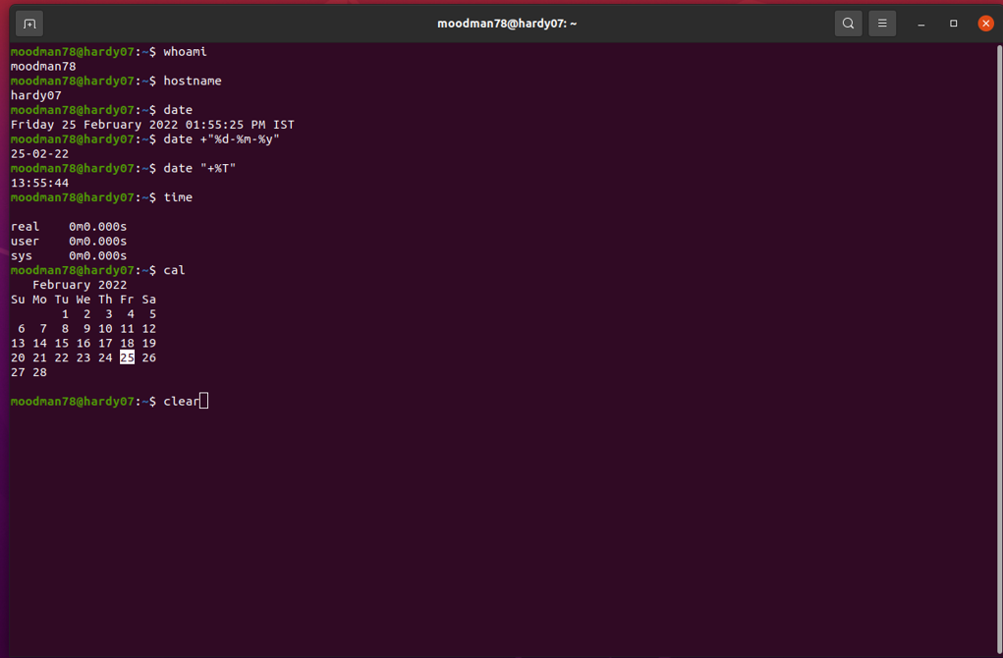

*AFTER:*

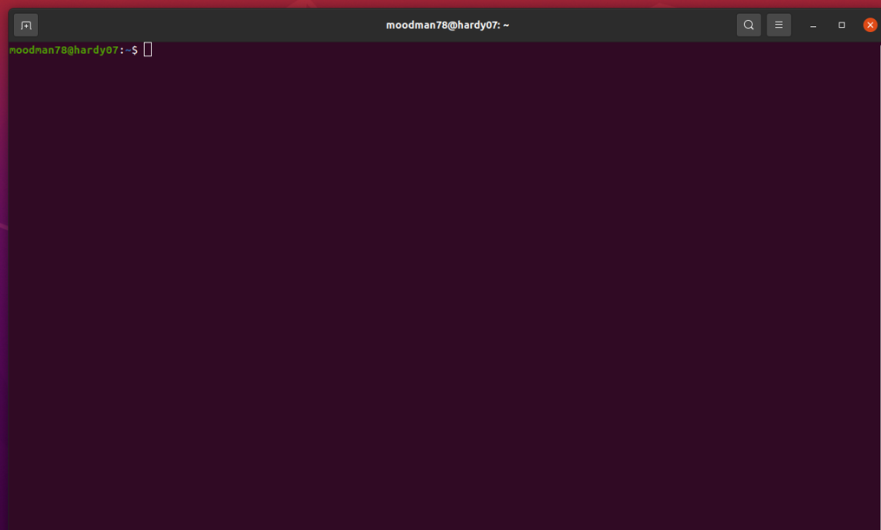

1. exit

*BEFORE:*

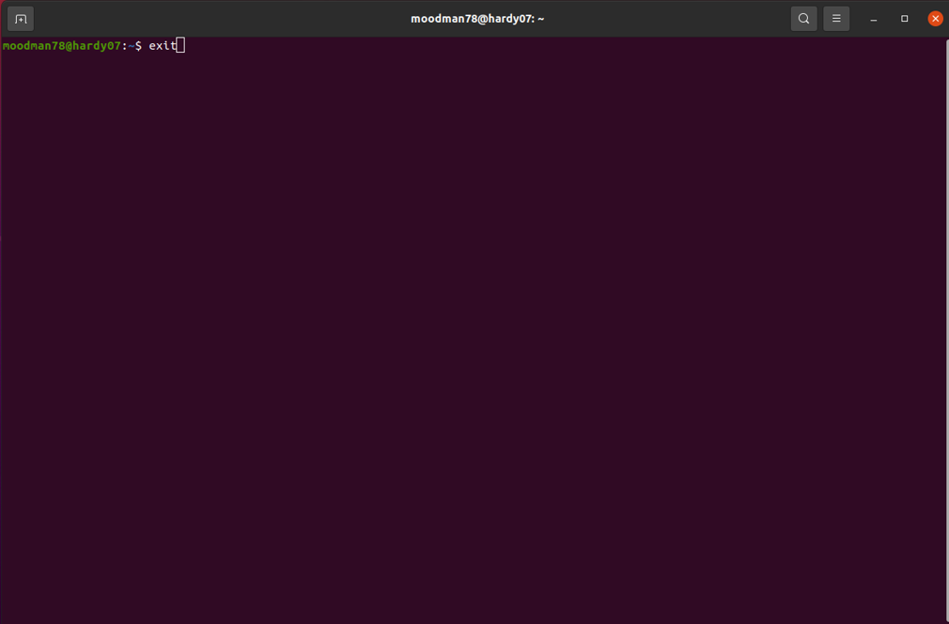

*AFTER:*

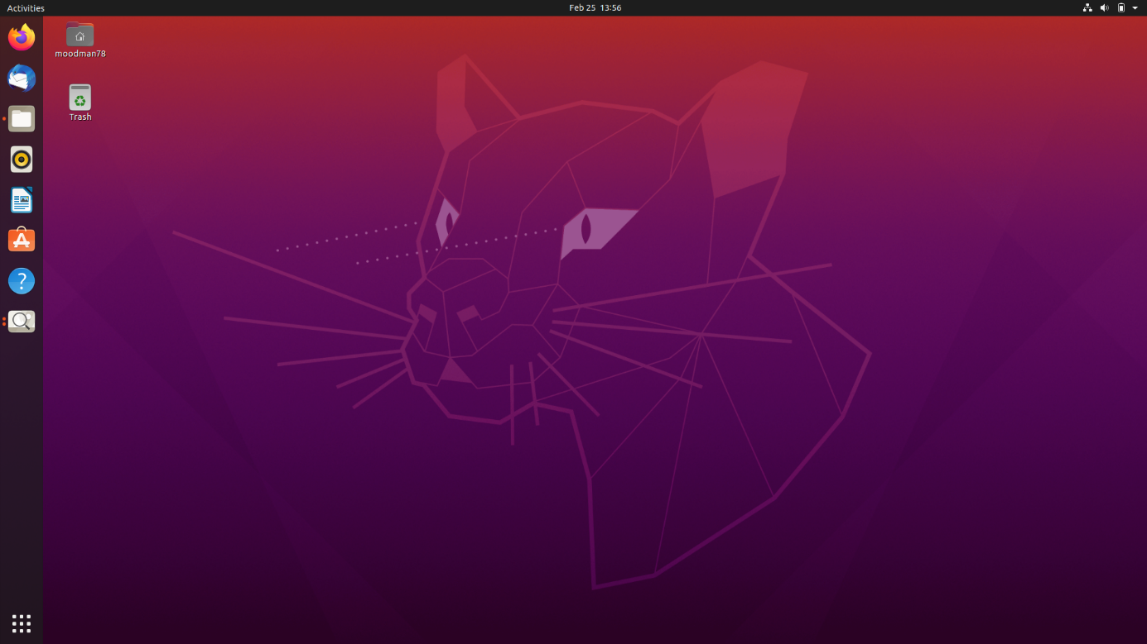

1. pwd



1. ls



1. cd, mkdir

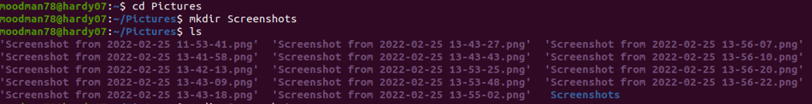

1. rmdir

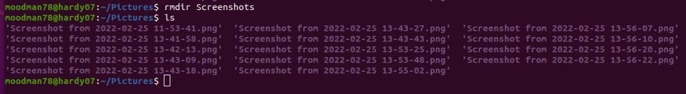

1. rm, touch

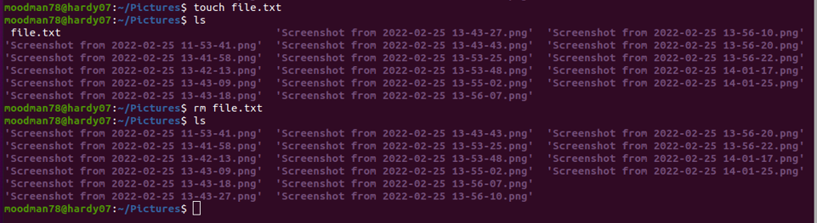

1. cp



1. mv



1. find



1. locate



1. man

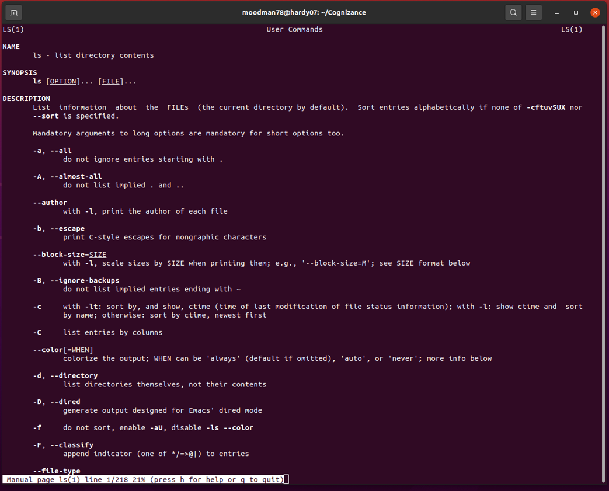

1. echo



1. cat

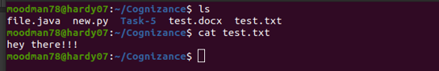

1. head, tail

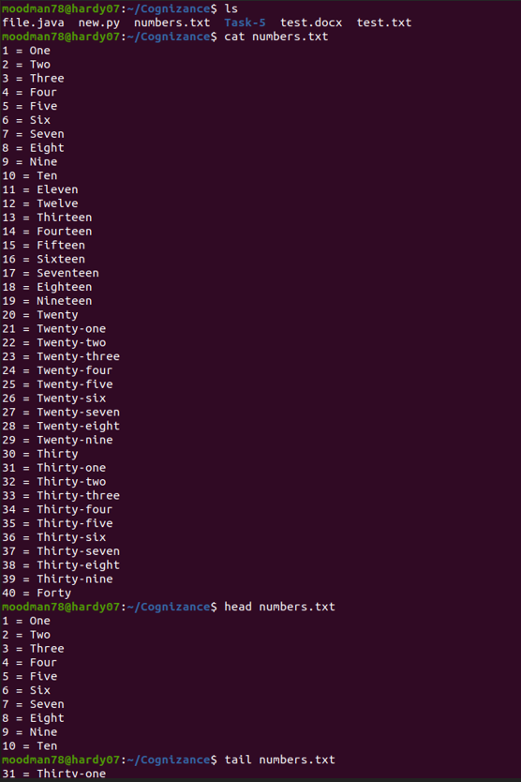

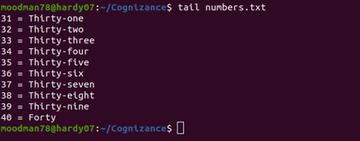

1. grep

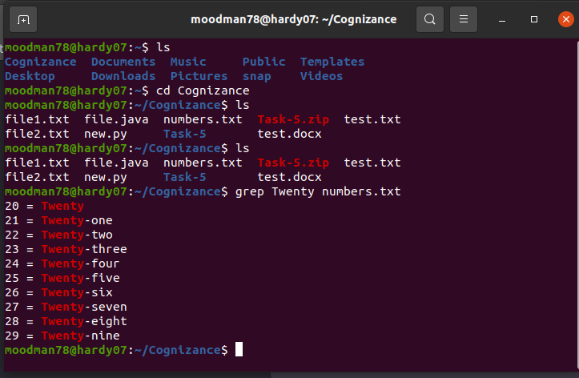

1. diff

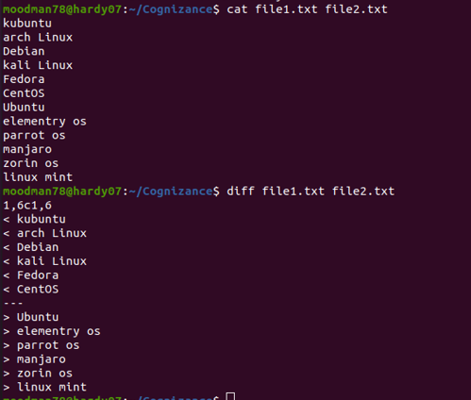

1. sudo

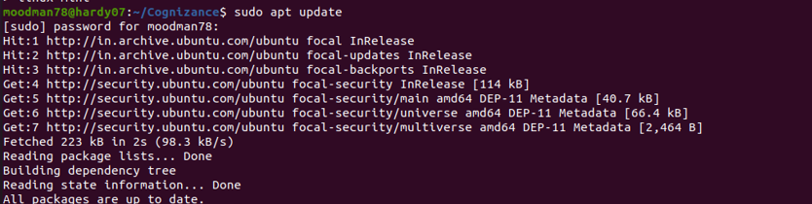

1. df

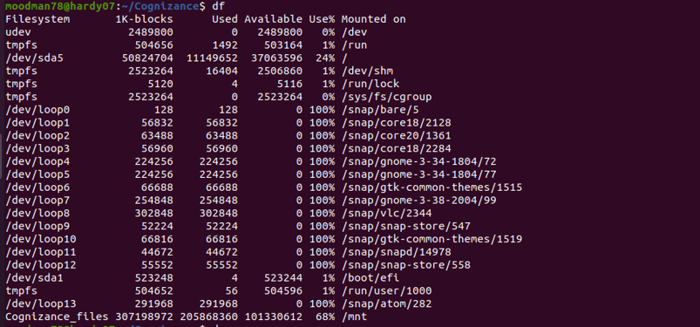

1. du

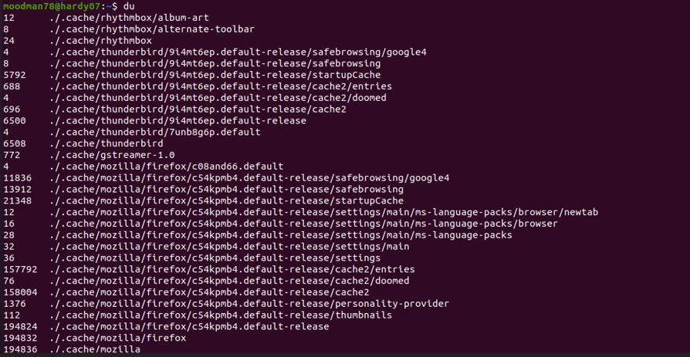

1. zip, unzip





1. tar



1. chmod

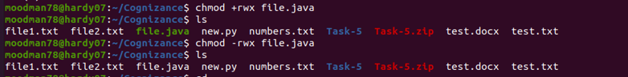

1. apropos

